**EXPERIMENT 10**

**Aim : (a)** Write a program in C/C++ to find the largest of 3 numbers. The test suite selected by a testing technique is given below-

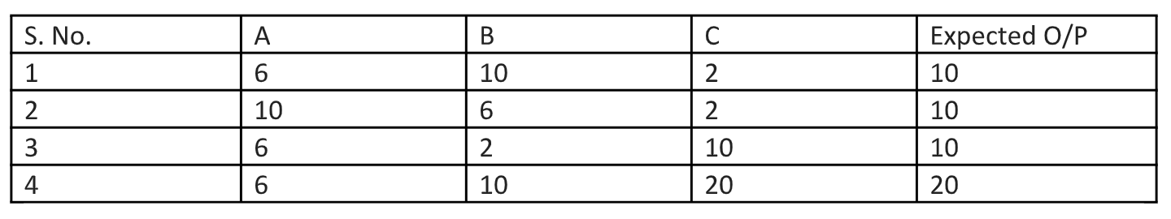

Create 5 Mutants (M1 to M5) and calculate Mutation Score of this test suite.

**Algorithm :**

* Take three numbers a, b and c as input from the user.
* If (a > = b) and (a > = c) then Largest number is a.
* Else If (b > = a) and (b > = c) then Largest number is b.
* Else the Largest number is c.

**Code :**

**1.** int main()

**2.** {

**3.**     int a, b, c;

**4.**     cout << "Enter Three Numbers (a, b, c) : ";

**5.**     cin >> a >> b >> c;

**6.**     if ((a >= b) && (a >= c))

**7.**         cout << "Largest Number : " << a;

**8.**     else if (b >= c)

**9.**         cout << "Largest Number : " << b;

**10.**    else

**11.**        cout << "Largest Number : " << c;

**12.**    return 0;

**13.**}

**Output Screenshot :**

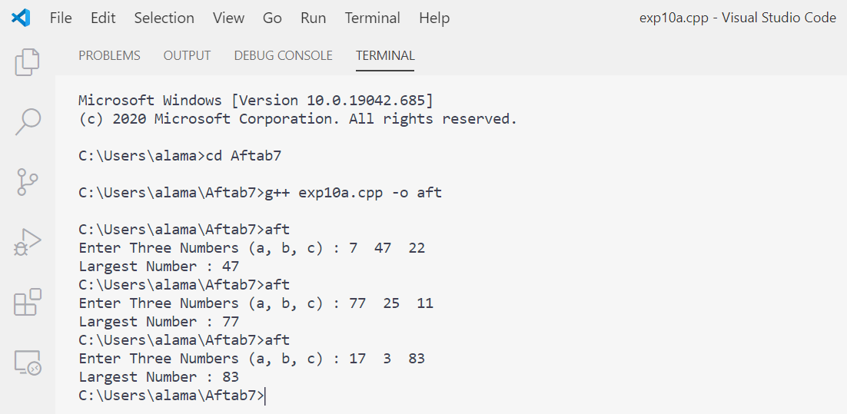

**Mutation Testing :** We will create Mutants for the above program as:

* ***Mutant 1 – M1***

**1.** int main()

**2.** {

**3.** int a, b, c;

**4.** cout << "Enter Three Numbers (a, b, c) : ";

**5.** cin >> a >> b >> c;

**6.** if ((c >= a) && (c <= b)) **//changing the if condition in terms of c**

**7.**     cout << "Largest Number : " << a;

**8.** else if (b >= c)

**9.**     cout << "Largest Number : " << b;

**10.**else

**11.**    cout << "Largest Number : " << c;

**12.**return 0;

**13.**}

* ***Mutant 2 – M2***

**1.** int main()

**2.** {

**3.** int a, b, c;

**4.** cout << "Enter Three Numbers (a, b, c) : ";

**5.** cin >> a >> b >> c;

**6.** if ((a == b) && (a >= c)) **//replacing >= by ==**

**7.**     cout << "Largest Number : " << a;

**8.** else if (b >= c)

**9.**     cout << "Largest Number : " << b;

**10.**else

**11.**    cout << "Largest Number : " << c;

**12.**return 0;

**13.**}

* ***Mutant 3 – M3***

**1.** int main()

**2.** {

**3.** int a, b, c;

**4.** cout << "Enter Three Numbers (a, b, c) : ";

**5.** cin >> a >> b >> c;

**6.** if ((a >= b) && (a >= c)) **//replacing && by ||**

**7.**     cout << "Largest Number : " << a;

**8.** else if (b >= c)

**9.**     cout << "Largest Number : " << b;

**10.**else

**11.**    cout << "Largest Number : " << c;

**12.**return 0;

**13.**}

* ***Mutant 4 – M4***

**1.** int main()

**2.** {

**3.** int a, b, c;

**4.** cout << "Enter Three Numbers (a, b, c) : ";

**5.** cin >> a >> b >> c;

**6.** if ((a >= b) && (a >= c))

**7.**     cout << "Largest Number : " << c; **//replacing a by c**

**8.** else if (b >= c)

**9.**     cout << "Largest Number : " << b;

**10.**else

**11.**    cout << "Largest Number : " << c;

**12.**return 0;

**13.**}

* ***Mutant 5 – M5***

**1.** int main()

**2.** {

**3.** int a, b, c;

**4.** cout << "Enter Three Numbers (a, b, c) : ";

**5.** cin >> a >> b >> c;

**6.** if ((b >= a) && (b >= c)) **//changing the if condition in terms of b**

**7.**     cout << "Largest Number : " << a;

**8.** else if (b >= c)

**9.**     cout << "Largest Number : " << b;

**10.**else

**11.**    cout << "Largest Number : " << c;

**12.**return 0;

**13.**}

**Mutants Test Cases Table**

|  |  |  |  |  |  |  |
| --- | --- | --- | --- | --- | --- | --- |
| **Mutant** | **Test Case** | **Input** | **Expected Output** | **Mutant Output** | **Test Result** | **Remark** |
| M1 | 1 | <6,10,2> | 10 | 10 | Fail | Killable |
| 2 | <10,6,2> | 10 | Program Terminates | Pass | Killed |
| 3 | <6,2,10> | 10 | 10 | Fail | Killable |
| 4 | <6,10,20> | 20 | 20 | Fail | Killable |
| M2 | 1 | <6,10,2> | 10 | 10 | Fail | Killable |
| 2 | <10,6,2> | 10 | Program Terminates | Pass | Killed |
| 3 | <6,2,10> | 10 | 10 | Fail | Killable |
| 4 | <6,10,20> | 20 | 20 | Fail | Killable |
| M3 | 1 | <6,10,2> | 10 | Program Terminates | Pass | Killed |
| 2 | <10,6,2> | 10 | 10 | Fail | Killable |
| 3 | <6,2,10> | 10 | Program Terminates | Pass | Killed |
| 4 | <6,10,20> | 20 | 20 | Fail | Killable |
| M4 | 1 | <6,10,2> | 10 | 10 | Fail | Killable |
| 2 | <10,6,2> | 10 | Program Terminates | Pass | Killed |
| 3 | <6,2,10> | 10 | 10 | Fail | Killable |
| 4 | <6,10,20> | 20 | 20 | Fail | Killable |
| M5 | 1 | <6,10,2> | 10 | 10 | Fail | Killable |
| 2 | <10,6,2> | 10 | Program Terminates | Pass | Killed |
| 3 | <6,2,10> | 10 | 10 | Fail | Killable |
| 4 | <6,10,20> | 20 | 20 | Fail | Killable |

**Mutation Score**

$$Mutation Score=\frac{100*No. of Killed Mutants}{(No. of Total Mutants-No. of Equivalent Mutants)}$$

Here,

No. of Killed Mutants = 5

No. of Total Mutants = 5

No. of Equivalent Mutants = 0

So,

**Mutation Score** = 100 * 5 / (5 - 0)

= 100 * 5 / 5

= **100**

**Aim : (b)** Write a program in C/C++ to determine the day of the given date and perform Slice-based testing for all variables.

**Algorithm :**

* Take three inputs from the user for day, month, and year.
* Calculate the day of the given date using the formula:

***Day = (d + m + y + [y / 4] + c) mod 7***

* Here, c stands for the century number.
* Find the day according to the calculated number of the day.
* Print the day of the given date as calculated.

**Code :**

**1.** int main()

**2.** {

**3.** int d, m, y;

**4.** cout << "Enter Date : ";

**5.** cin >> d;

**6.** cout << "Enter Month : ";

**7.** cin >> m;

**8.** cout << "Enter Year : ";

**9.** cin >> y;

**10.**const char *Names[] = {"Sunday", "Monday", "Tuesday", "Wednesday",

"Thursday", "Friday", "Saturday"};

**11.**int day = 0;

**12.**static int t[] = {0, 3, 2, 5, 0, 3, 5, 1, 4, 6, 2, 4};

**13.**y -= m < 3;

**14.**day = (y + y / 4 - y / 100 + y / 400 + t[m - 1] + d) % 7;

**15.**cout << "Day : " << Names[day] << endl;

**16.**return 0;

**17.**}

**Output Screenshot :**

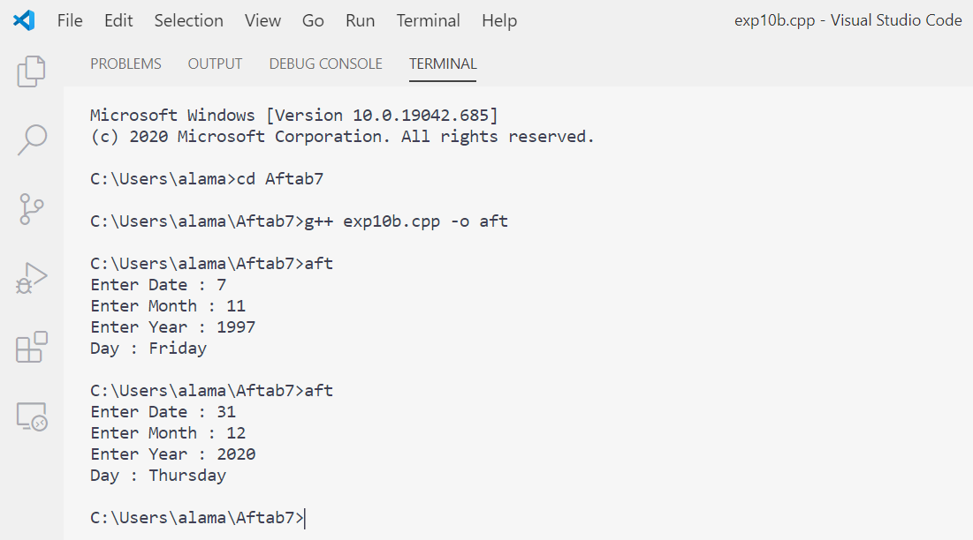

**Slice Based Testing :**

There is total 6 variables in the program. We can create slices for each of them.

* ***Variable: d***

**S(d,5) / S(d,17) = {1-5,17}**

**1.** int main()

**2.** {

**3.** int d, m, y;

**4.** cout << "Enter Date : ";

**5.** cin >> d;

**17.**}

* ***Variable: m***

**S(m,7) / S(m,17) = {1-3,6,7,17}**

**1.** int main()

**2.** {

**3.** int d, m, y;

**6.** cout << "Enter Month : ";

**7.** cin >> m;

**17.**}

* ***Variable: y***

**S(y,9) / S(y,17) = {1-3,8,9,17}**

**1.** int main()

**2.** {

**3.** int d, m, y;

**8.** cout << "Enter Year : ";

**9.** cin >> y;

**17.**}

**S(y,13) / S(y,17) = {1-3,8,9,13,17}**

**1.** int main()

**2.** {

**3.** int d, m, y;

**8.** cout << "Enter Year : ";

**9.** cin >> y;

**13.**y -= m < 3;

**17.**}

* ***Variable: Names***

**S(Names,10) = {1-2,10,17}**

**1.** int main()

**2.** {

**10.**const char *Names[] = {"Sunday", "Monday", "Tuesday", "Wednesday",

"Thursday", "Friday", "Saturday"};

**17.**}

**S(Names,15) / S(Names,17) = {1-17}**

**1.** int main()

**2.** {

**3.** int d, m, y;

**4.** cout << "Enter Date : ";

**5.** cin >> d;

**6.** cout << "Enter Month : ";

**7.** cin >> m;

**8.** cout << "Enter Year : ";

**9.** cin >> y;

**10.**const char *Names[] = {"Sunday", "Monday", "Tuesday", "Wednesday",

"Thursday", "Friday", "Saturday"};

**11.**int day = 0;

**12.**static int t[] = {0, 3, 2, 5, 0, 3, 5, 1, 4, 6, 2, 4};

**13.**y -= m < 3;

**14.**day = (y + y / 4 - y / 100 + y / 400 + t[m - 1] + d) % 7;

**15.**cout << "Day : " << Names[day] << endl;

**16.**return 0;

**17.**}

* ***Variable: day***

**S(day,11) = {1-2,11,17}**

**1.** int main()

**2.** {

**11.**int day = 0;

**17.**}

**S(day,14) / S(day,17) = {1-14,16,17}**

**1.** int main()

**2.** {

**3.** int d, m, y;

**4.** cout << "Enter Date : ";

**5.** cin >> d;

**6.** cout << "Enter Month : ";

**7.** cin >> m;

**8.** cout << "Enter Year : ";

**9.** cin >> y;

**10.**const char *Names[] = {"Sunday", "Monday", "Tuesday", "Wednesday",

"Thursday", "Friday", "Saturday"};

**11.**int day = 0;

**12.**static int t[] = {0, 3, 2, 5, 0, 3, 5, 1, 4, 6, 2, 4};

**13.**y -= m < 3;

**14.**day = (y + y / 4 - y / 100 + y / 400 + t[m - 1] + d) % 7;

**16.**return 0;

**17.**}

* ***Variable: t***

**S(t,12) / S(t,17) = {1-2,12,17}**

**1.** int main()

**2.** {

**12.**static int t[] = {0, 3, 2, 5, 0, 3, 5, 1, 4, 6, 2, 4};

**17.**}

**Test Cases :**

|  |  |  |  |  |  |  |
| --- | --- | --- | --- | --- | --- | --- |
| **S. No.** | **Slice** | **Lines Covered** | **Variables** | | | **Expected Output** |
| **d** | **m** | **y** |
| 1 | S(d,5) / S(d,17) | 1-5,17 | 12 |  |  | No Output |
| 2 | S(m,7) / S(m,17) | 1-3,6,7,17 |  | 4 |  | No Output |
| 3 | S(y,9) | 1-3,8,9,17 |  |  | 2019 | No Output |
| 4 | S(y,13) / S(y,17) | 1-3,8-9,1317 |  |  | 2019 | No Output |
| 5 | S(Names,10) | 1-2,10,17 |  |  |  | No Output |
| 6 | S(Names,15) / S(Names,17) | 1-17 | 12 | 4 | 2019 | Friday |
| 7 | S(day,11) | 1-2,11,17 |  |  |  | No Output |
| 8 | S(day,14) / S(day,17) | 1-14,16,17 | 12 | 4 | 2019 | No Output |
| 9 | S(t,12) / S(t,17) | 1,2,12,17 |  |  |  | No Output |